Time Range: 6.29 – 7.3
Requirements: Map Topology Design and Coding
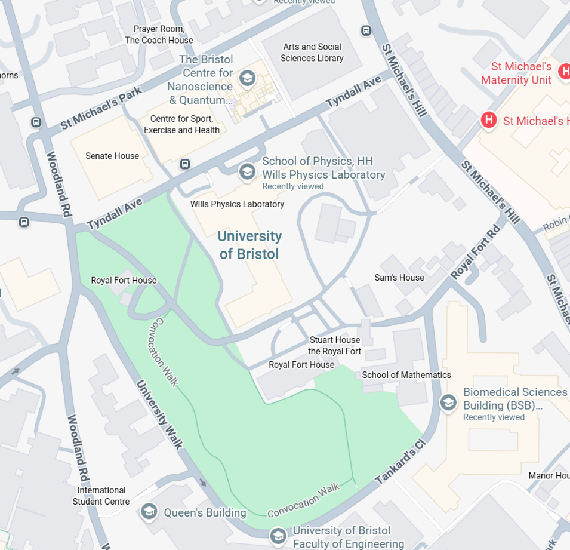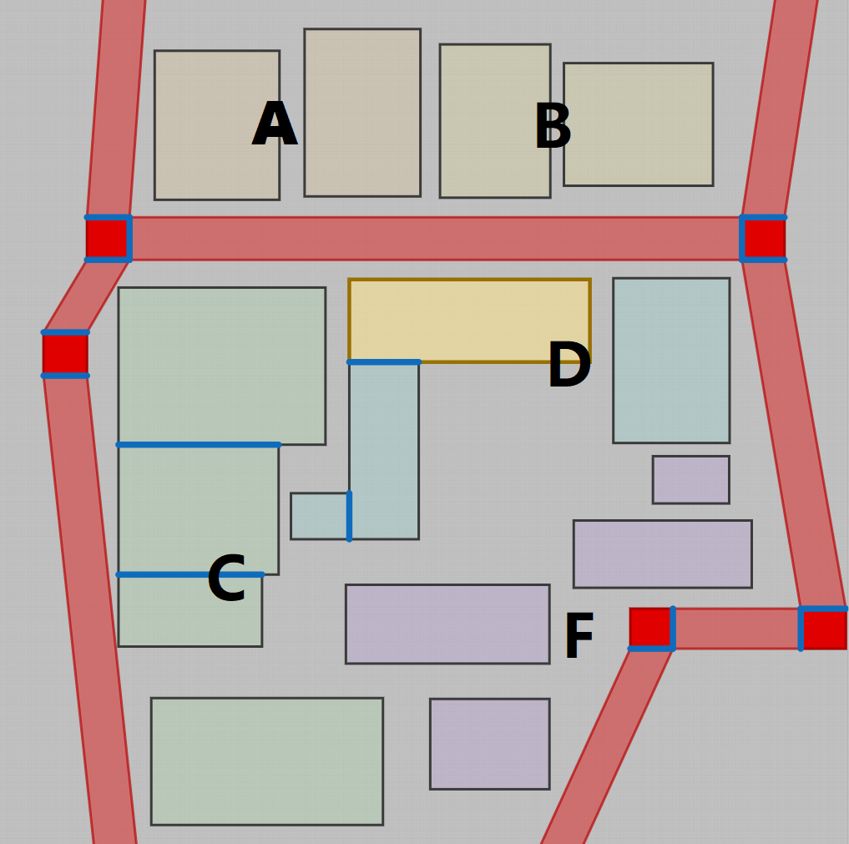
Background：
Area A：
- Student Activity Center (Senate Housing)
- GYM (Centre for Sport, Exercise and Health)

Area B:
- Research Center (The Bristol Centre for Nanoscience & Quantum Information)
- Library (Arts and Social Sciences Library)

Area C (outdoor):
- Large Lawn (Royal Fort Gardens)
- Soccer Field (No matches)

Area D:
- School Building (School of Physics)
- Administration Building (School of Biological Sciences, not matches)

Area E:
- En-suite Residence
- Co-living Space
- Single-Family Home
- Coffee Shop

Important Notes:
- You can use this diagram as a reference for the specific design (Even conducting on-site visits):
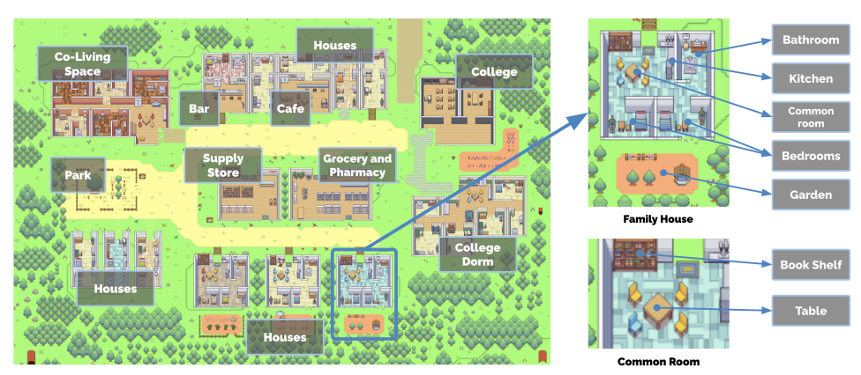
- You need to submit at least one set of floor plans, which must include the building areas under your responsibility, key obstacles and decorative elements, walls, and portals.
- Different areas within the building must be distinguished, and these areas must be separated by walls. These areas must not contain any slanted edges. You must determine the location of the single entrance.
- The scene will eventually need to be implemented in code. If you have time, you can use the map editor in the project to design the scene and export the scene file as JSON to speed up our work.

